LINUX COMMANDS

1. mkdir: The mkdir stands for 'make directory'. With the help of mkdir command, you can create a new directory wherever you want in your system.
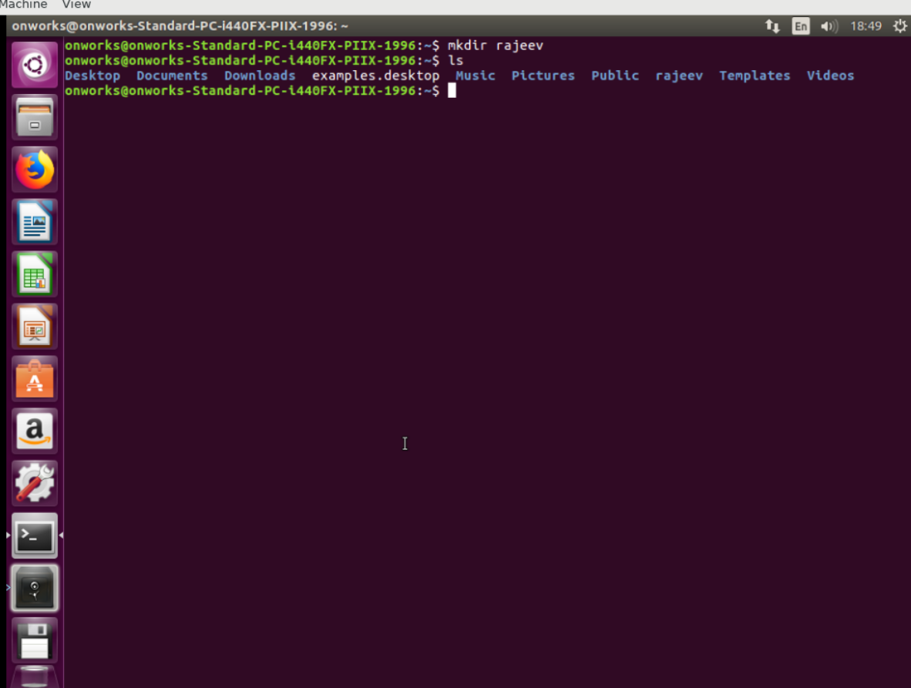

2. ls: The Ls command is used to get a list of files and directories. Options can be used to get additional information about the files.

ls -a: Lists the directories and files along with hidden files and directories.
ls -l: Lists the files with their properties.

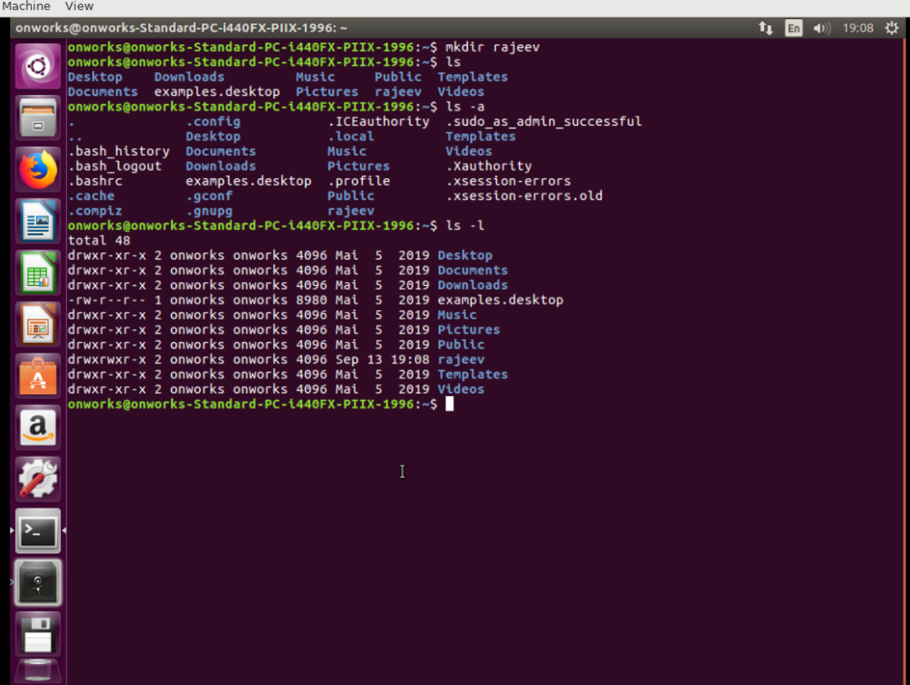

3. cd: Command cd is used to navigate between directories in Linux. In fact, cd stands for ‘change directory’.
cd ..: This option is used to navigate back to previous directories.
cd /: This option is used to redirect to root directory.

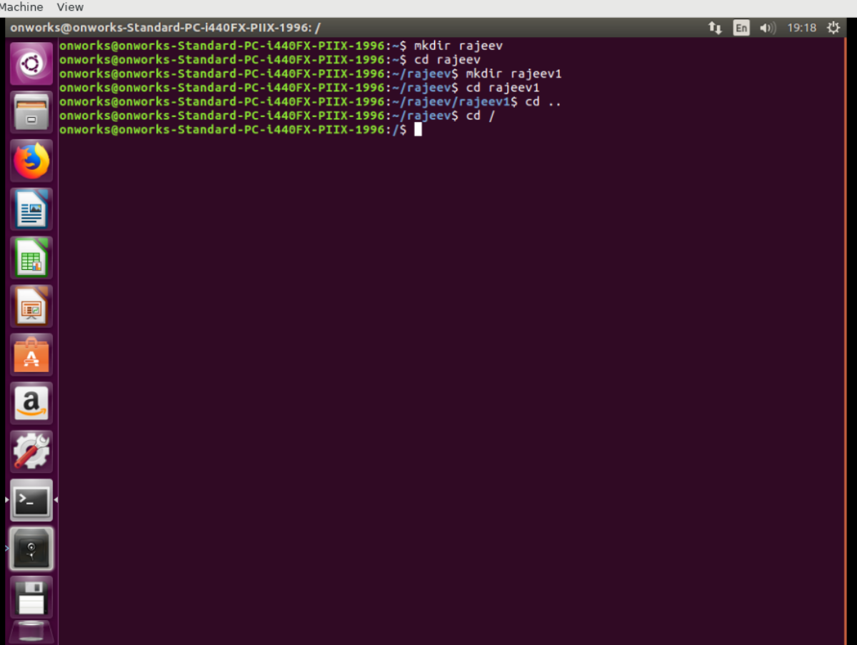
4. pwd: Present work directory, this display on which directory user working on.

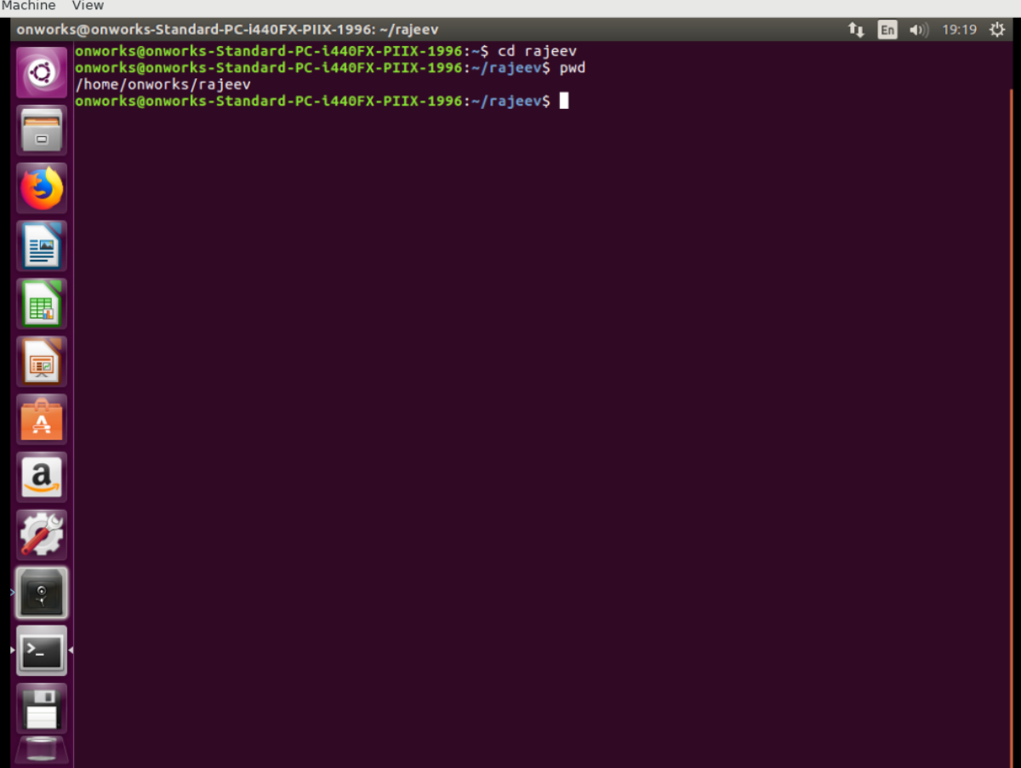
5. rmdir: This command is used remove empty directory.

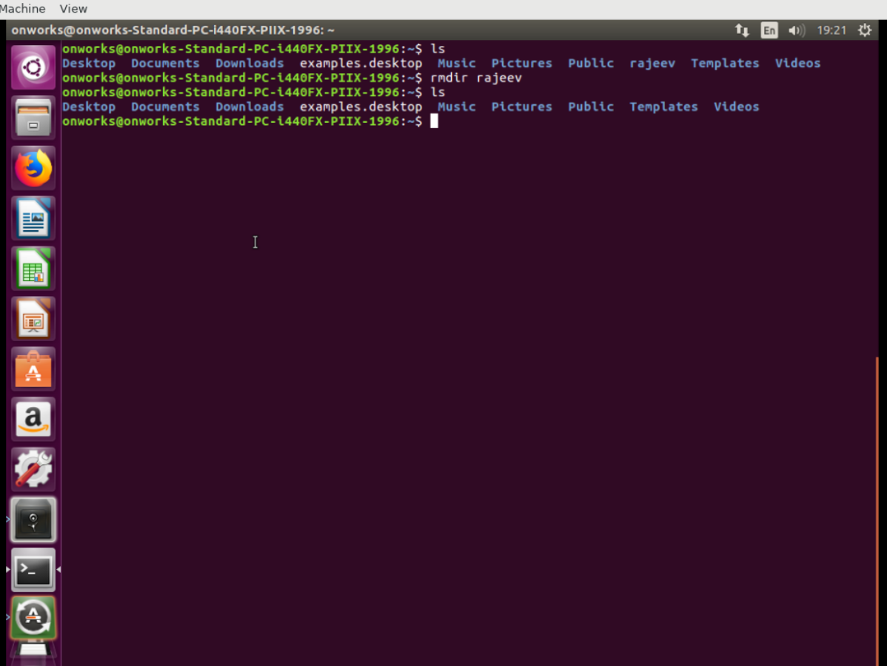
6. clear: This command is used to clear the console.

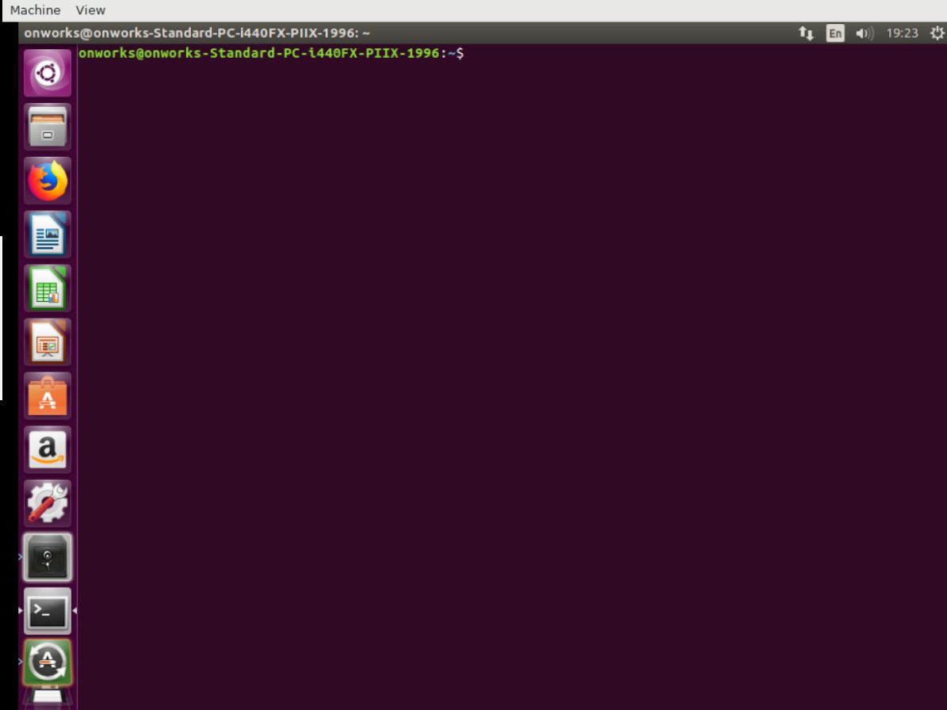
7. man: This command is used to get manual of any command.

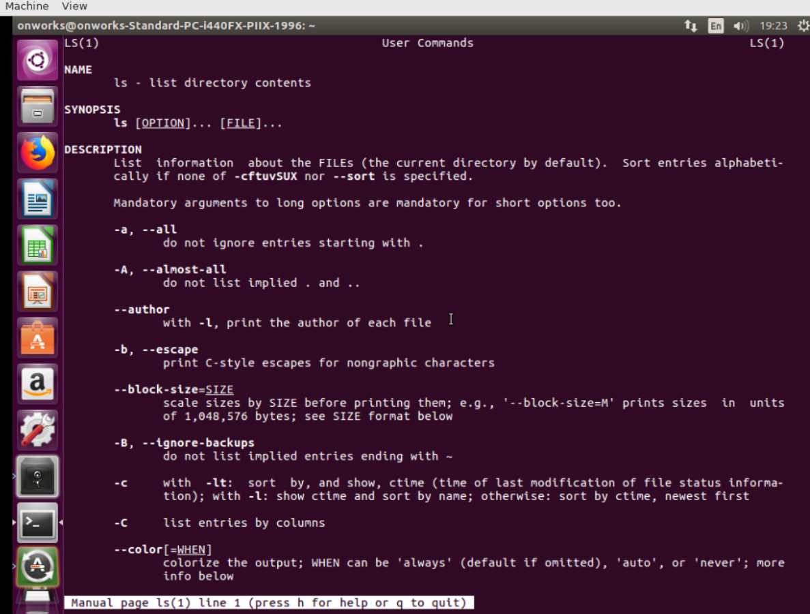

8. vi: This command is used to open notepad editor.

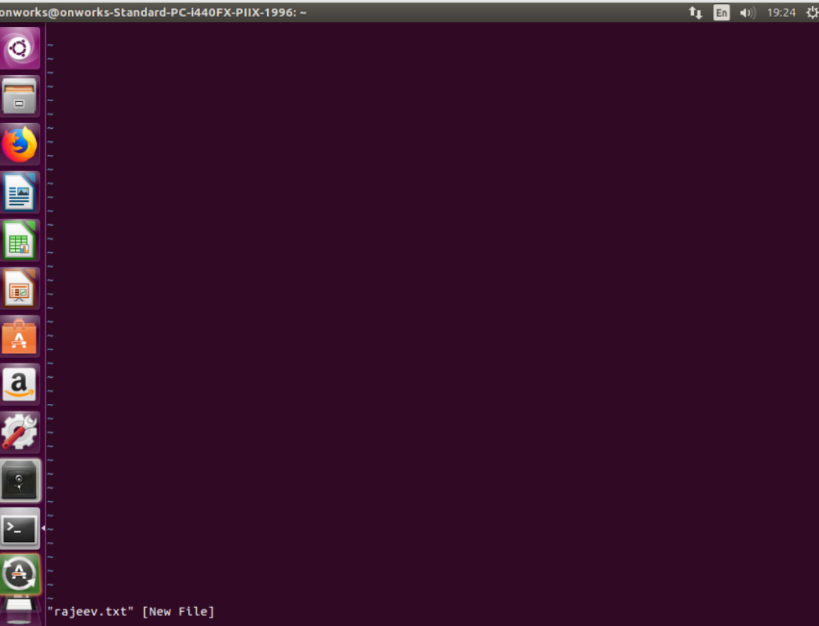

9. Touch: This command is used to create different kind of files without editing and saving.

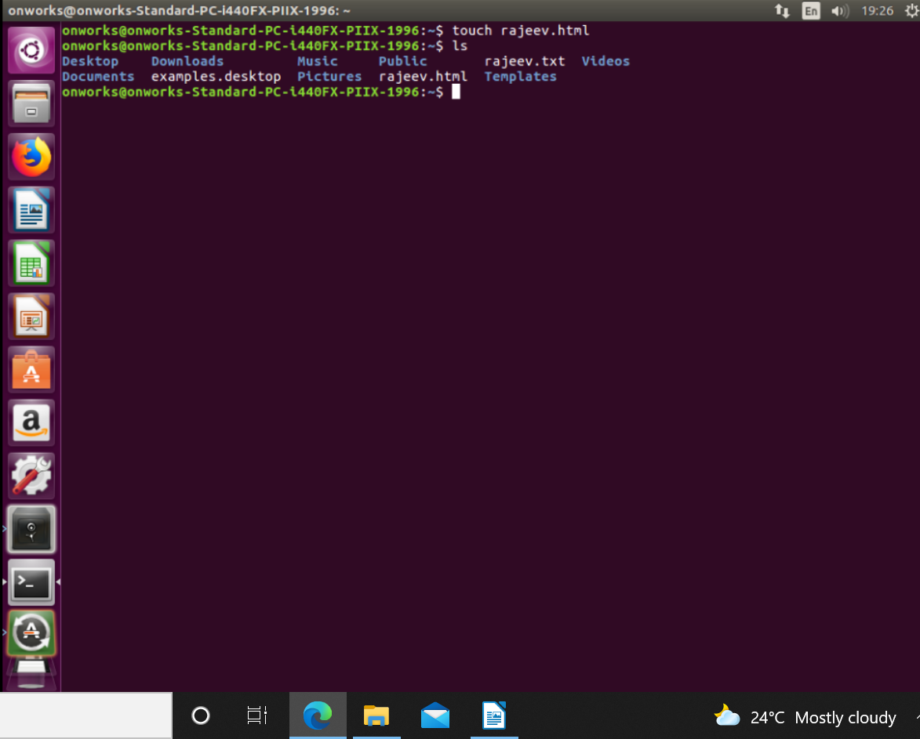

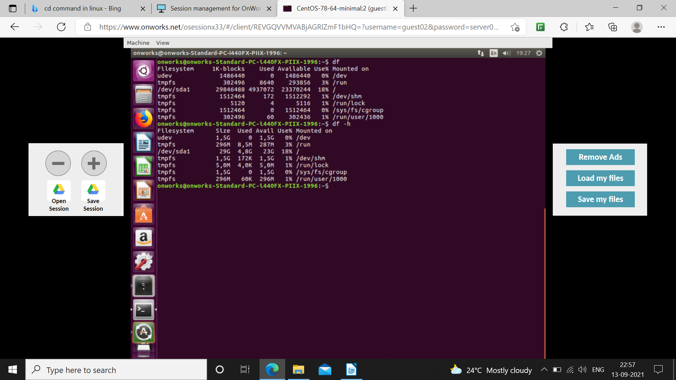
10. df: This command is used to display disk storage management.

11. ps: This command is used to display status of all the running processes.

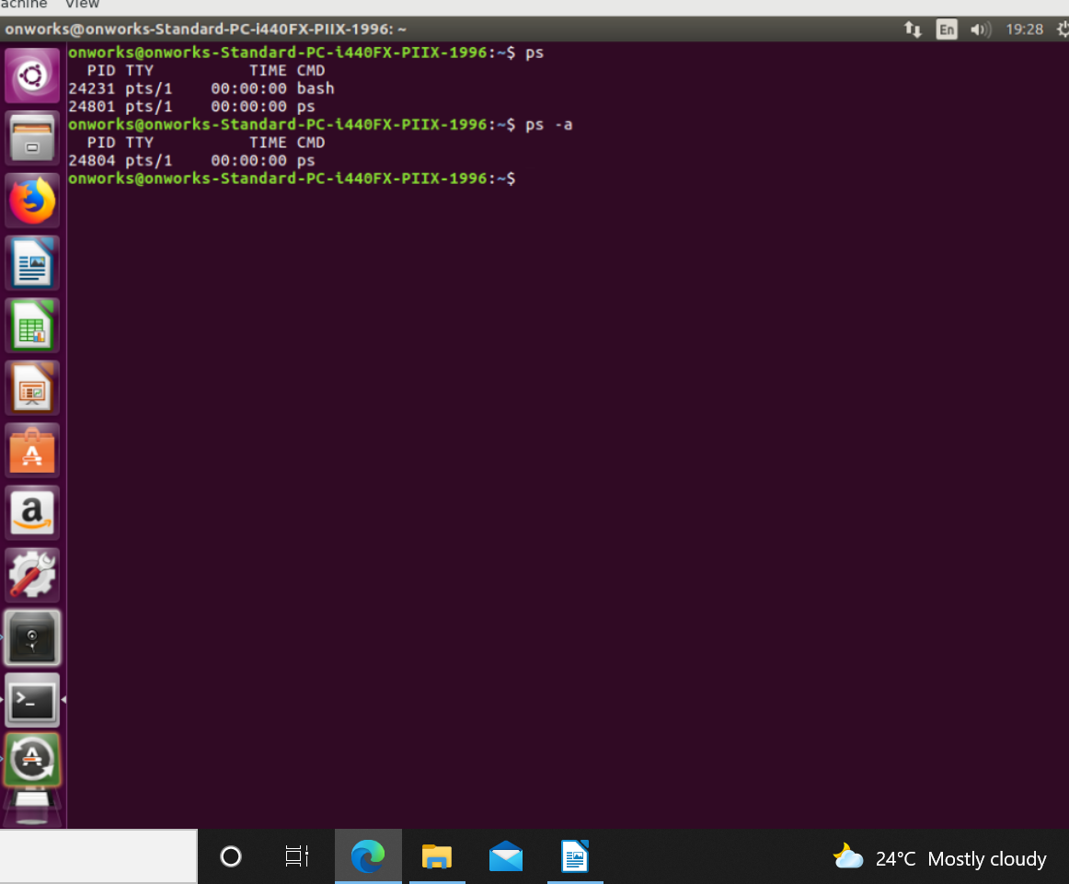

12. gedit: This command is used to create and open notepad.

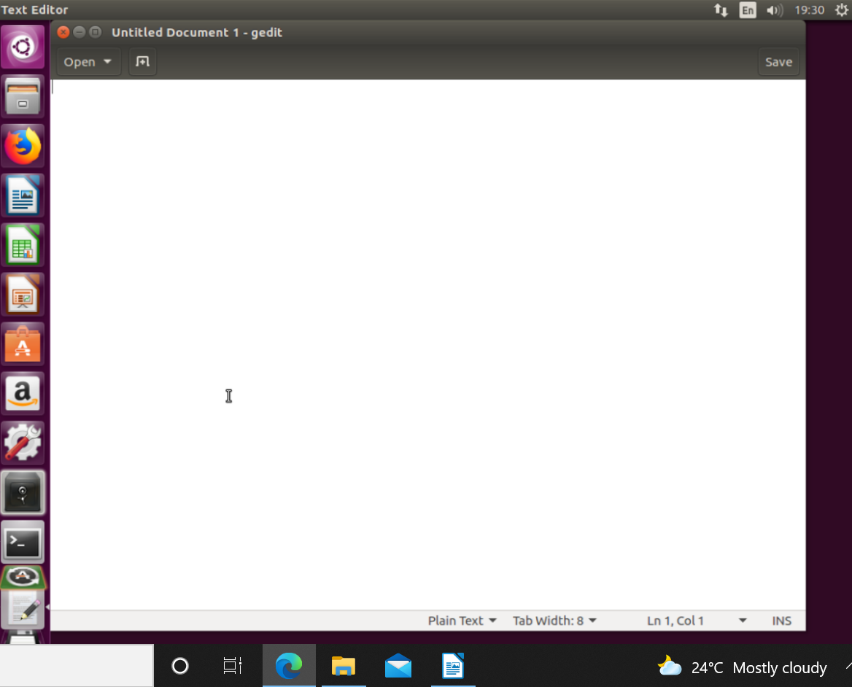

13. kill: Terminates all the processes or specified process.

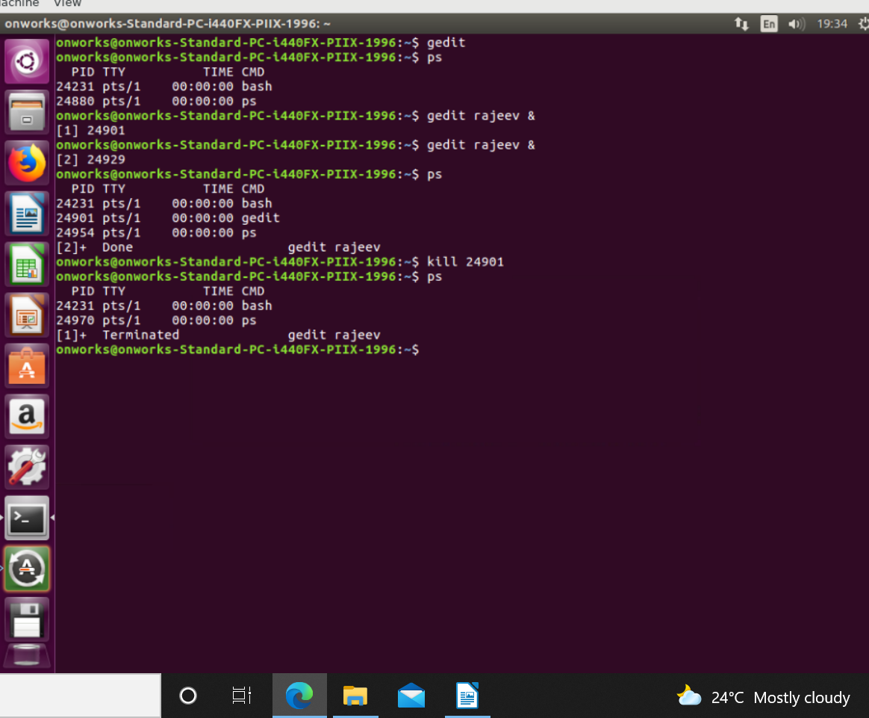

14. free: This command is used to display memory usage statistics.

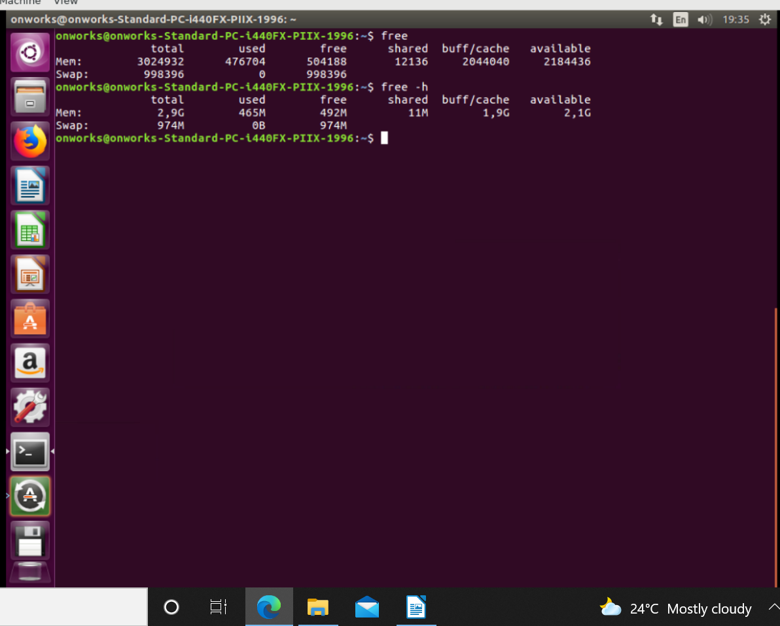

15. lshw: Lists the system configuration.
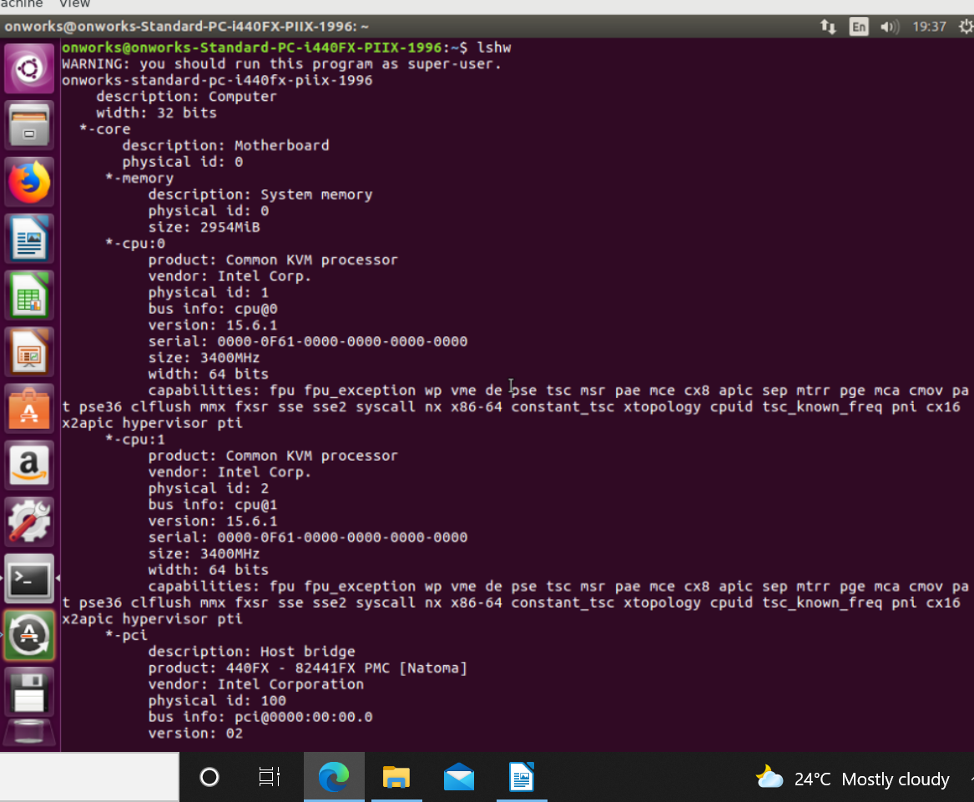

16. lscpu: This command is used to display cpu information.

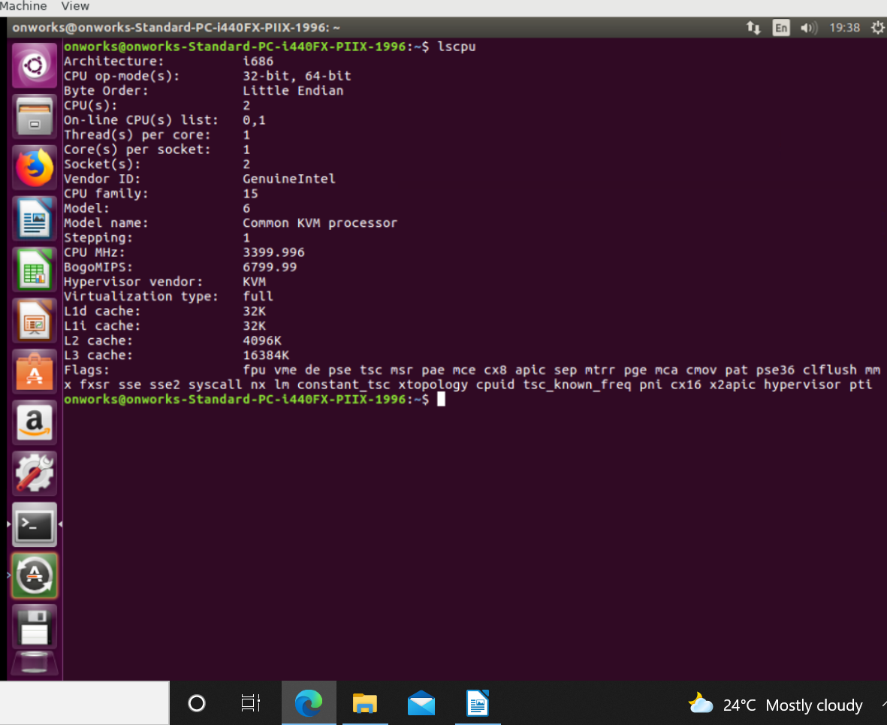

17. lsusb: This command is used to display information about usb inserted to the system.

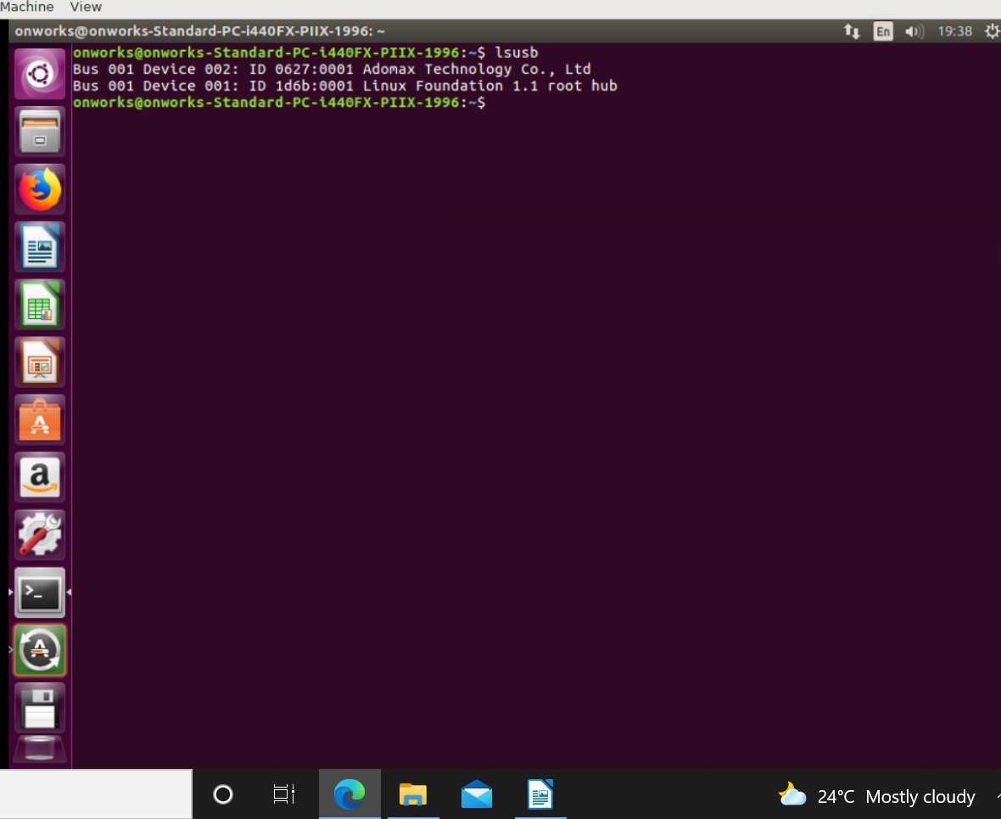

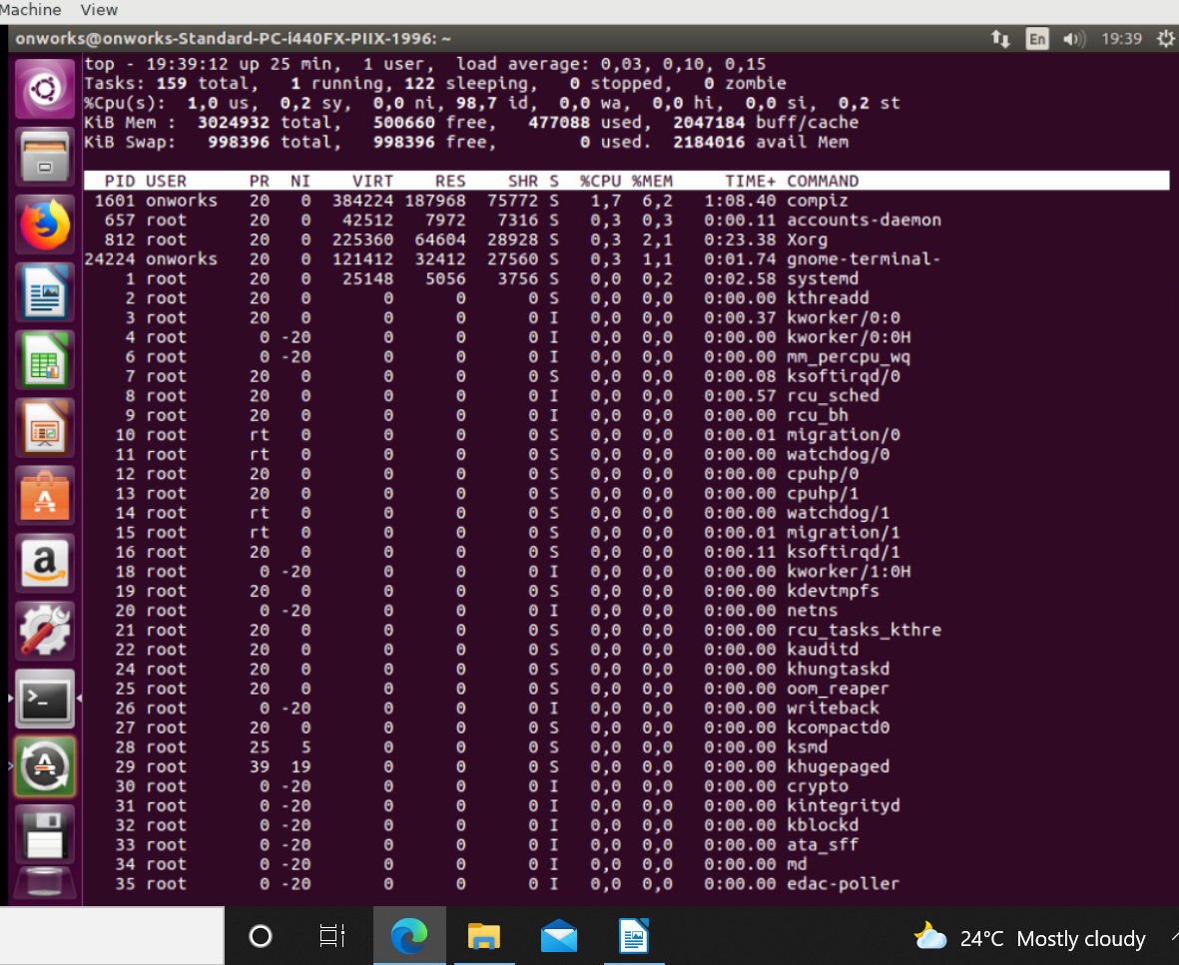
18. top: Displays all the information of user and system processes.

19. cat: This command is used to display contents of file specified.

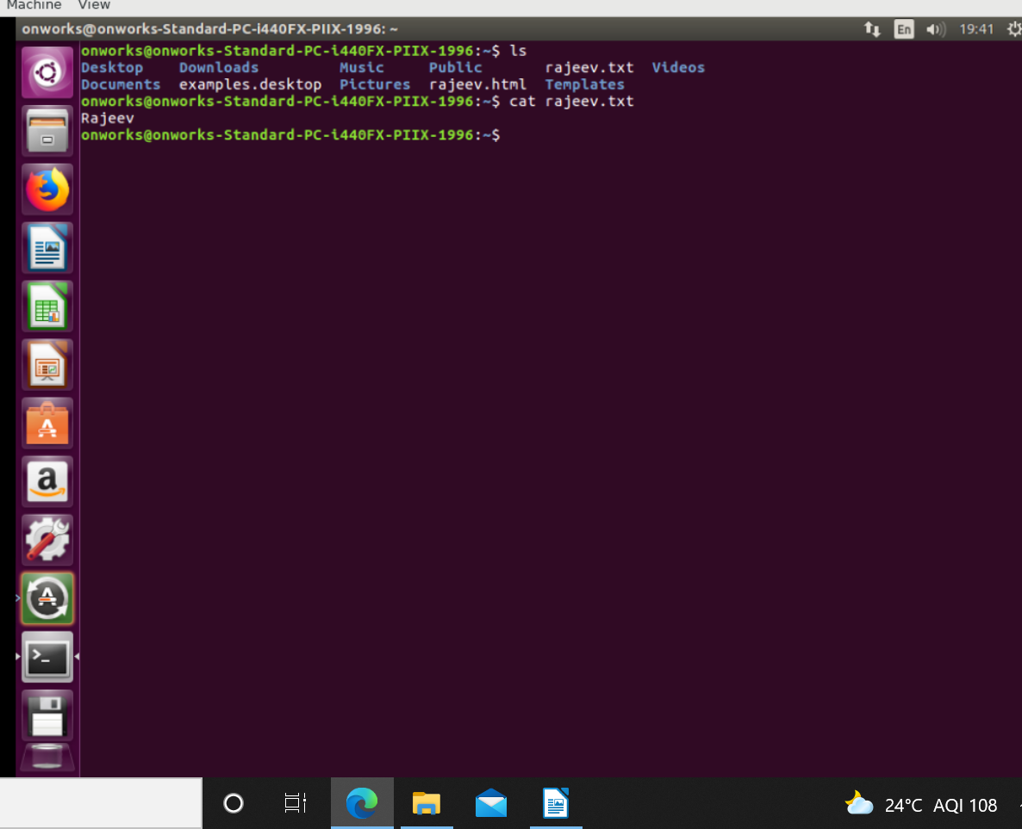

20. cat >filename: This option is used to take inputs from the keyboard as content of file specified.
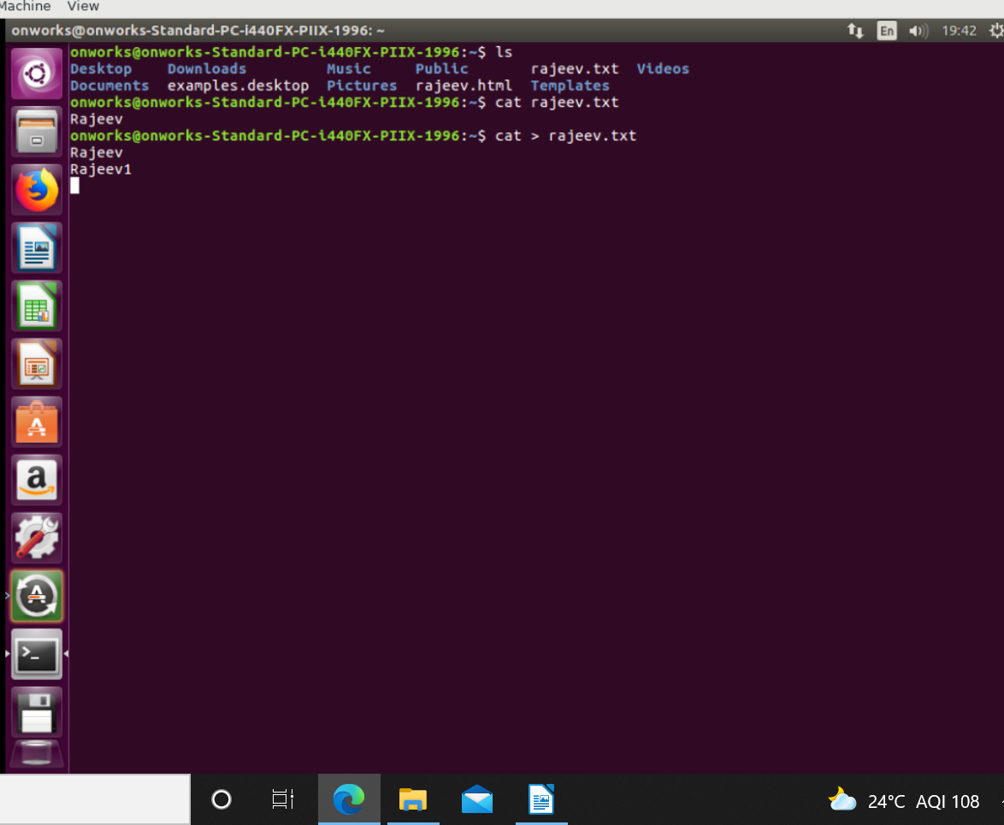

21. echo: This command is used to display or print exact content as specified by echo command.


